
kpmg.com
KPMG. Make the Difference.
May 2026
AR Intelligence
A unified approach to proactively manage Accounts Receivable, improve cash flow, and reduce risk.

Contents
1. Document control 3
1.1 Change record 3
1.2 Reviewers 3
1.3 Approvals 3
2. Solution overview 4
2.1 Key Features & Solution Highlights 5
3. Target operating model 6
3.1 Use case impacts on the design layer of the TOM 6
3.2 TOM layer details: AR Intelligence 6
3.3 KPMG leading practices and design decisions – Details 7
4. Implementation and SAP best practice 8
4.1 Configuration and SAP best practice 8
5. Demo script 9
5.1 Demo script overview 9
5.2 Approach 9
5.3 Demo steps 9
6. Deployment approach 10
7. Further information 11
7.1 Future development roadmap 11
7.2 Primary enhancements 11
7.3 Operational efficiency enhancements 11
Contact us 12

The information contained herein is of a general nature and is not intended to address the circumstances of any particular individual or entity. Although we endeavor to provide accurate and timely information, there can be no guarantee that such information is accurate as of the date it is received or that it will continue to be accurate in the future. No one should act on such information without appropriate professional advice after a thorough examination of the particular situation.

Document control

Change record
Version | Author | Date | Revision
1.0 | Martin Seo | May 27, 2026 | Initial version

Reviewers
This document has been reviewed by:
 | Reviewer | Date reviewed
<Sr.No.> | <Reviewer Name> | < Review Date>
<Sr.No.> | <Reviewer Name> | < Review Date>
<Sr.No.> | <Reviewer Name> | < Review Date>
<Sr.No.> | <Reviewer Name> | < Review Date>

Approvals
This document has been approved by:
 | Name | Signature | Date approved
<Sr.No.> | <Approver Name> | <Approver’s Signature> | <Approval Date>
<Sr.No.> | <Approver Name> | <Approver’s Signature> | <Approval Date>
<Sr.No.> | <Approver Name> | <Approver’s Signature> | <Approval Date>
<Sr.No.> | <Approver Name> | <Approver’s Signature> | <Approval Date>

Solution overview
The AR Intelligence solution is designed to transform Accounts Receivable from a reactive reporting function into a proactive, data-driven strategy. It addresses the critical challenge of lacking predictive visibility into cash flow, which directly impacts liquidity management, forecasting accuracy, and working capital efficiency. By replacing manual, judgment-based processes with AI-empowered tools, the primary objective is to optimize cash flow, sharpen forecast accuracy, and prioritize collection efforts for maximum impact.
The solution provides unified AR Intelligence on a cohesive SAP Business Data Cloud (BDC) landscape, moving far beyond static reporting to offer real-time, predictive insights. The architecture seamlessly orchestrates several powerful SAP components: SAP Datasphere is used for data integration and creating a governed semantic layer for consistent, reusable analytics; SAP Databricks is leveraged for developing and hosting sophisticated machine learning models for payment prediction and risk scoring; and SAP Analytics Cloud (SAC) serves as the interactive front-end for dynamic dashboards, reporting, and self-service analytics.
Predictive Intelligence is a core capability, utilizing machine learning to forecast when open invoices will be paid based on historical payment behaviors. This enables the system to automatically generate a Prioritized Collections Worklist, ensuring the team focuses on high-value, high-risk accounts. Furthermore, the solution offers Interactive Analysis, allowing users to drill down from high-level KPIs to specific customer and invoice details to find the root causes of delays. It also features AI-Powered Business Insights through natural language queries ('Just Ask') for instant visual answers and 'Smart Insights' that automatically analyze data to explain metric changes.
By empowering finance teams to anticipate cash flow and identify risks before they escalate, AR Intelligence delivers significant business impact. It enables proactive collections, optimizes cash inflows, and reduces overdue exposure, leading to improved cash realization. This strategic approach moves an organization from reactive problem-solving to proactive, data-driven decision-making, ensuring greater financial stability and control.
Lower
DSO
Increased Efficiency
Enhanced Visibility
The solution is designed to reduce overdue exposure and accelerate cash realization.
AI-powered worklists and insights increase collection efficiency by prioritizing high-impact accounts.
The solution improves cash flow forecasting and provides strategic visibility for working capital decisions.

Key Features & Solution Highlights
The AR Intelligence architecture is designed to fundamentally optimize the order-to-cash lifecycle through several key technological features:
93%
- Machine Learning Payment Forecasting: The system continuously analyzes historical payment data to generate predictive models, forecasting the exact likelihood of on-time payments for every open invoice.
- Automated Risk Scoring & Task Generation: Rather than relying on static aging buckets, the solution automatically generates daily, dynamically prioritized task lists for collection agents based on the highest calculated risk of default.
- Interactive Root-Cause Analysis: Built within SAP Analytics Cloud, the interface allows users to perform interactive drill-downs—moving from aggregate regional KPIs to specific customer behaviors and disputed document types in seconds.
of CFOs and CIOs report increased collaboration due to AI, their responsibilities often remain separate.
The AR Intelligence solution acts as a vital orchestration tool that bridges this gap. By creating a unified "single source of truth," it aligns IT's focus on data integrity with Finance's need for actionable insights, fostering true strategic alignment.
- Conversational Data Exploration: The integration of AI assistants empowers business users to interact with their data conversationally. Users can ask questions like "Show me top overdue customers in EMEA" and receive instant, auto-generated charts.
- Quantifiable Business Impact: When fully deployed, these integrated features drive significant operational improvements, including a significant reduction in manual analytical effort and a measurable improvement in overall Days Sales Outstanding (DSO).

- Operational Efficiency: Automating these insights minimizes manual analysis time, drastically reducing reliance on IT for ad-hoc reporting.
The AR Intelligence solution empowers finance teams with the forward-looking insights needed to anticipate cash flow, identify risks before they escalate, and make strategic decisions that improve the organization's overall financial health.

Target operating model
The KPMG Target Operating Model (TOM) is a holistic framework that defines how an organization operates and delivers value. It shapes business transformation across every layer of the enterprise, providing a proven, future-ready solution set built on KPMG’s functional and industry-leading practices. Comprising six distinct design layers, the TOM ensures that strategic changes are seamlessly codified and implemented across the entire organization.
Velocity works hand-in-hand with the Target Operating Model (TOM) to translate strategic design into execution. By combining global TOM designs and tailored value stream blueprints - spanning various industries, sectors, and technologies - with Velocity’s pre-configured journeys, enablers, and automation, organizations can significantly accelerate their transformation. This integration ensures that strategic design and technical delivery remain seamlessly connected, presenting users with the exact TOM enablers required for their specific platform, sector, or functional journey.

Use case impacts on the design layer of the TOM
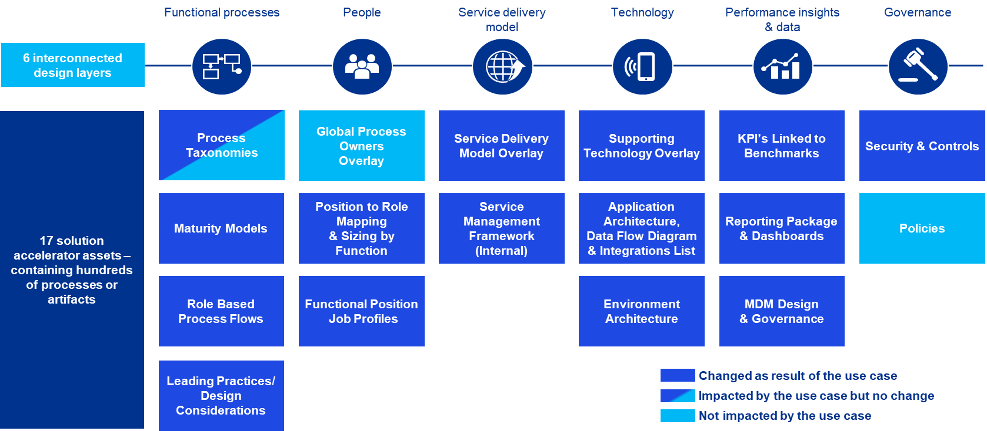

TOM layer details: AR Intelligence
The Account Receivable (AR) Intelligence solution through the framework of a Target Operating Model (TOM). It outlines six distinct operating model layers - Functional Processes, People, Service Delivery, Technology, Performance Insights, and Governance - and describes the specific assets and capabilities that the AR Intelligence solution delivers within each layer. The overarching theme is a fundamental shift in the functional process, moving from reactive aging analysis to a proactive, risk-based collections strategy. This transformation is driven by three core pillars: unifying AR data into a single analytical layer, applying machine learning models for predictive analysis of payment likelihood and risk, and generating dynamic worklists to direct collection teams to the highest-risk accounts.
The solution is designed to empower different user groups. For the People layer, it provides CFOs and Controllers with real-time visibility for strategic decisions on working capital, while Collections Managers can use ML-driven worklists to guide team efforts and improve efficiency. The Service Delivery Model is a centralized, self-service analytics platform delivered through an interactive SAP Analytics Cloud dashboard. This gives business users direct, on-demand access to trusted data and insights, significantly reducing their dependency on IT for standard reporting and ad-hoc queries. This model ensures that actionable intelligence is readily available to those who need it.
The Technology layer is built on a unified cloud architecture using the SAP Business Data Cloud. This ecosystem leverages SAP Datasphere for data integration and a governed semantic layer, SAP Databricks for developing and hosting the machine learning models, and SAP Analytics Cloud as the interactive front-end for dashboards and analytics. This robust architecture provides a single source of truth for all AR data, delivering real-time KPIs, predictive insights, and operational data with drill-down capabilities. Finally, the Governance layer is embedded via the SAP Datasphere semantic layer, which guarantees consistent data definitions, standardized KPIs, and trusted, reusable analytics across the enterprise.

KPMG leading practices and design decisions – Details
The leading practices are centered on transforming AR from a reactive, manual process into a proactive, data-driven function. On the process side, this involves shifting from aging reports to forward-looking strategies (Proactive AR), using dynamic, multi-factor risk scores to drive collections (Smart Prioritization), and empowering business users with analytics to reduce IT reliance (Self-Service). Technologically, these practices are supported by unifying AR data into a Single Source of Truth to eliminate manual reconciliation, leveraging Predictive Machine Learning to forecast payment behaviors, and embedding role-based dashboards directly into user workflows (Embedded Analytics). The potential benefits of adopting these practices include lower DSO and better cash flow, higher collection efficiency, and enhanced visibility for strategic working capital decisions.
The specific design considerations detail how these leading practices are implemented. The process is built around ML-Prioritized Workflows, where collection activities are designed around a dynamic worklist prioritized by ML-driven risk scores from SAP Databricks, fundamentally shifting the focus from static aging to predictive risk. It also incorporates natural language queries like "Just Ask" and "Smart Insights" through Joule on SAC stories. Technologically, the architecture is built on a suite of SAP products: pulling AR data directly from S/4HANA Data Products, using SAP Datasphere to build a centralized and governed semantic layer, leveraging SAP Databricks to develop ML models with secure, zero-copy Delta Sharing, and using SAP Analytics Cloud as a live-connected, interactive front-end.
Ultimately, these design choices result in significant benefits. They create a Scalable Architecture with a clean separation between data warehousing and advanced analytics, ensuring the solution can grow with the business. They enforce Strong Governance by creating a single version of the truth through the semantic layer, which guarantees data consistency and reliability. Finally, the solution delivers Real-Time Insights, providing immediate, decision-ready data through live connections, which empowers the organization to act with speed and confidence.

Transitioning to technical execution
To successfully operationalize these Target Operating Model layers, a structured configuration approach must be followed. The following section outlines the critical configuration activities and SAP best practices required to transition these theoretical TOM layers into functional technical realities.

Implementation and SAP best practice

Configuration and SAP best practice
Use Case AR Intelligence configuration activities:
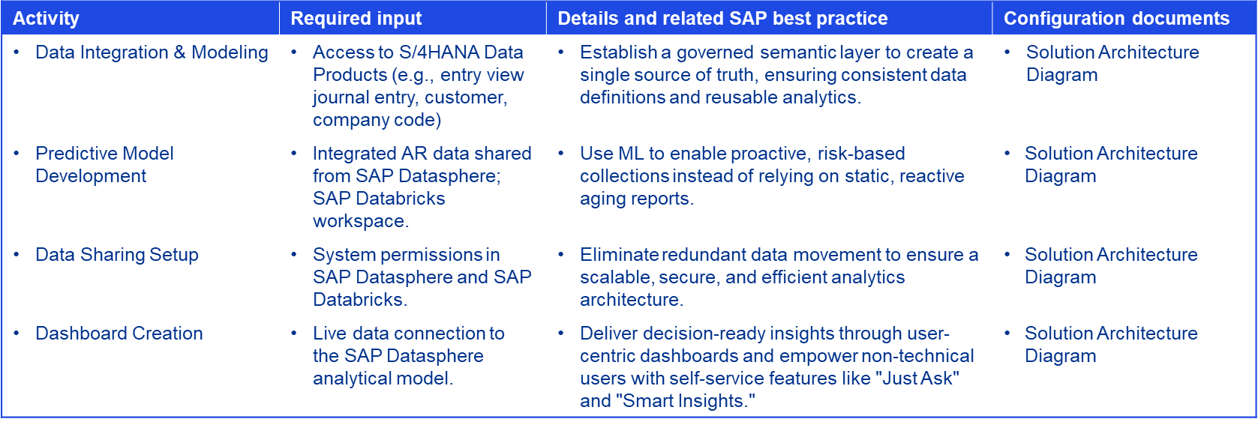

Demo script
This demonstration is structured as a “Day-in-the-Life” journey. It begins with the CFO identifying a global DSO leak on the executive dashboard, transitions to the Collections Manager deploying an automated, prioritized worklist to mitigate the issue, and concludes with an analyst using natural language queries to pinpoint root-cause payment barriers.

Demo script overview
The AR Intelligence demo illustrates the solution's capacity to transition finance organizations from reactive tracking to proactive, data-driven decision-making. The script is tailored for two primary personas: the CFO/Financial Controller (high-level oversight) and the Financial Manager (granular analysis).
To ensure a seamless presentation, several technical prerequisites must be met: the SAP Datasphere model must be refreshed, the SAP Databricks ML models must be run to generate current predictions, and the SAP Analytics Cloud (SAC) environment must be opened to the main dashboard.

Approach
The demo employs a “top-down” narrative, starting with an executive-level view and drilling down into operational details. A central theme is emphasizing the system as a “Single Source of Truth” by showing both personas using the same unified dashboard to ensure data consistency. The presentation is focused on three core value pillars: real-time visualization, predictive risk modeling, and self-service analytics.

Demo steps
The demonstration workflow is conducted through four sequential phases:
- Phase 1: Dashboard KPI Review. The session begins with an examination of critical AR metrics (DSO, On-Time Payment Rate, Total Overdue) on the main dashboard, including geographic performance analysis using the interactive map.
- Phase 2: Overdue Balance Investigation. The presenter analyzes the drivers behind late payments, highlighting SAC’s ability to automatically identify and visualize the top contributing customers or document types without manual data manipulation.
- Phase 3: Self-Service Ad-hoc Analysis. The demo highlights user empowerment with the “Just Ask” natural language query tool, showing how users can input conversational questions to instantly generate visual insights and explore data.
- Phase 4: Proactive Collections Action. The focus shifts to operational execution by reviewing the prioritized collections worklist. This demonstrates how ML-driven risk scores from SAP Databricks dynamically guide teams to target high-impact accounts.

Deployment approach
The implementation of the Account Receivable Intelligence solution follows a rapid, structured hack-to-build deployment methodology. This framework is designed to ensure strict alignment between business objectives and technical execution while minimizing time-to-value. The delivery model is organized into three sequential phases: Discover & Design, Build & Test, and Deploy & Support. Each phase features defined activities and strict milestone gates to ensure quality and project governance.
Phase 1: Discover & Design
The initial phase is dedicated to establishing project alignment, gathering business requirements, and defining the target architecture.
- Key Activities: The project commences with a formal use case Kick-Off, followed by detailed requirements gathering and solution design. During this period, the technical architecture is established, and specific KPIs and dashboard visualizations are defined in collaboration with key stakeholders.
- Milestones & Deliverables: Progression to the next phase is contingent upon the completion of key deliverables, including the project Kick-Off Deck, a formalized Technical Architecture document, and officially Signed-off Functional Specifications that serve as the blueprint for development.
Phase 2: Build & Test
The core technical development and system validation occur during this intensive phase.
- Key Activities: Technical teams execute system configuration across SAP Business Technology Platform (BTP) and SAP Databricks. This is followed by complex data integration and modeling, the development of the machine learning predictive models, and the iterative build of the SAP Analytics Cloud (SAC) dashboards. The phase concludes with rigorous User Acceptance Testing (UAT) to validate system accuracy and usability.
- Milestones & Deliverables: Critical milestones validating the success of this phase include the readiness of the BTP environment, successful data extraction to the Business Data Cloud (BDC), the delivery of the fully built dashboard, and a completed Test Plan accompanied by formal UAT sign-off.
Phase 3: Deploy & Support
The final phase focuses on organizational enablement, transitioning the solution into production, and ensuring sustained adoption.
- Key Activities: Activities are centered on conducting comprehensive end-user training sessions, finalizing go-live preparations, and providing dedicated "hypercare" support immediately following the launch to quickly address any operational issues.
- Milestones & Deliverables: The project is officially concluded upon the delivery of finalized Training Materials, the execution of the formal Go-Live Plan, and the acquisition of Final Sign-off from project sponsors, marking the transition to standard operational support.

Further information

Future development roadmap
The future development roadmap for the Account Receivable Intelligence solution is focused on introducing new capabilities that further enhance risk management, operational efficiency, and predictive accuracy. These planned enhancements are designed to expand the solution's value and provide even deeper, more proactive insights for the finance organization. The roadmap includes four key areas for future development: strengthening credit controls, identifying high-risk customers, automating cash application, and enriching data for more precise risk profiling.

Primary enhancements
A primary focus of future enhancements is on proactive credit risk mitigation. This will be achieved by developing Credit Limit Breach Indicators, which will provide real-time monitoring of customers exceeding their credit limits. This feature is designed to reduce bad debt risk and offer better visibility to CFOs and risk management teams. In parallel, a High Write-Off Customer Identification model is planned. This classification model will analyze the frequency and value of historical write-offs to automatically flag high-risk accounts early, enabling more targeted and timely intervention before accounts become uncollectible.

Operational efficiency enhancements
To improve operational efficiency, an Unapplied Cash Monitoring system is a key planned enhancement. This system will actively monitor unapplied cash and create automated triggers for manual clearing, which will significantly improve the speed and accuracy of the cash application process. Finally, to enrich the solution's predictive capabilities, External Data Integration is a critical part of the future strategy. This involves integrating external data sources, such as credit scores from agencies like Dun & Bradstreet, to create a more comprehensive and accurate customer risk profile. By incorporating this external data, the solution's predictive models will become even more powerful and precise.


Next Steps
Schedule a Discovery Workshop: Contact our team to schedule a 1-hour scoping session where we can map the AR Intelligence solution directly to your current SAP landscape and business objectives.

Contact us

Martin Seo
Platforms - SAP
T: +1 (408) [210 4797]
E: martinseo@kpmg.com

Siva Vankayalapati
Finance & EPM
T: +1 (346) [387 2103]
E: sivavankayalapati@KPMG.com

Parag Shrivastava
Platforms - SAP
T: +1 (347) [491 9382]
E: paragshrivastava1@KPMG.com

Some or all of the services described herein may not be permissible for KPMG audit clients and their affiliates or related entities.
kpmg.com



The information contained herein is of a general nature and is not intended to address the circumstances of any particular individual or entity. Although we endeavor to provide accurate and timely information, there can be no guarantee that
such information is accurate as of the date it is received or that it will continue to be accurate in the future. No one should act on such information without appropriate professional advice after a thorough examination of the particular situation.
© 2026 Copyright owned by one or more of the KPMG International entities. KPMG International entities provide no services to clients. All rights reserved.
KPMG refers to the global organization or to one or more of the member firms of KPMG International Limited (“KPMG International”), each of which is a separate legal entity. KPMG International Limited is a private English company limited by
guarantee and does not provide services to clients. For more details about our structure please visit kpmg.com/governance.
The KPMG name and logo are trademarks used under license by the independent member firms of the KPMG global organization.
Throughout this document, “we”, “KPMG”, “us” and “our” refers to the KPMG global organization, to KPMG International Limited (“KPMG International”), and/or to one or more of the member firms of KPMG International, each of which is a
separate legal entity.
KPMG’s participation and contribution in this regard is not an endorsement, sponsorship or implied backing of any company’s products or services.

